**Code (HTML tags)**

* Use **Robots meta tag**
  + Default value is follow, index
  + <meta name=”robots” content=[parameter]>
  + E.g <meta name=”robots” content=[follow,noindex]>
* Use **canonical link element** to avoid duplicate content
  + If you have the same content on multiple pages on your website, you’ll have duplicate content
  + A canonical tag (aka "rel canonical") is a way of telling search engines that a specific URL represents the master copy of a page.
  + Add canonical url to all pages.
  + For e.g. crawler can reach a specific page using the following url:
    - www.pykih.com/mohit
    - www.pykih.com/mohitnihalani
    - www.pykih.com/organiziation/mohit
  + To avoid crawling issues use canonical tags:
  + Add a rel=canonical link from the non-canonical page to the canonical one. So if we picked the shortest URL as our canonical URL, the other URL would link to the shortest URL in the <head> section of the page – like this:
  + <link rel="canonical" href="http://pykih.com/mohit/" />
* Use descriptive **alt tags** for the url
  + Always add alt tags for the images
  + In case of a **linked image**, the alt text should be the title of the page it’s linking to.
  + Alt tag should contain keyphrase.
* Use **structured data**
  + **Use** [**schema.org**](https://schema.org/)to loop for structured data markup supported by the search engines.
  + Use JSON-ld to create structured markup and insert that markup in head of the page:
  + E.g. markup of recipe

<script type="application/ld+json">

{

"@context": "http://schema.org",

"@type": "Recipe",

"author": "John Smith",

"cookTime": "PT1H",

"datePublished": "2009-05-08",

"description": "This classic banana bread recipe comes from my mom -- the walnuts add a nice texture and flavor to the banana bread.",

"image": "bananabread.jpg",

"recipeIngredient": [

"3 or 4 ripe bananas, smashed",

"1 egg",

"3/4 cup of sugar"

],

"interactionStatistic": {

"@type": "InteractionCounter",

"interactionType": "http://schema.org/Comment",

"userInteractionCount": "140"

},

"name": "Mom's World Famous Banana Bread",

"nutrition": {

"@type": "NutritionInformation",

"calories": "240 calories",

"fatContent": "9 grams fat"

},

"prepTime": "PT15M",

"recipeInstructions": "Preheat the oven to 350 degrees. Mix in the ingredients in a bowl. Add the flour last. Pour the mixture into a loaf pan and bake for one hour.",

"recipeYield": "1 loaf",

"suitableForDiet": "http://schema.org/LowFatDiet"

}

</script>

* + Use tools such as [Structure Data testing](https://search.google.com/structured-data/testing-tool/u/0/) to check any errors in JSON-LD.
* Add keywords on the **h1 tag** of the page.
* Include **meta tags** such as **meta description** and **meta title** and make sure these contains keywords.
* Add descriptive **anchor text.**
  + **Anchor text** which links to other pages should contain keywords of the page and should describe what the page is about.
  + Never just link the url.

**Images**

* **Preparing your Images**
  + Find and select the right image.
    - Always find unique and original images which matches your mission or topic of content.
  + Choose a right file name
    - Google uses the file name to determine what an image is about. That’s why you should use your focus keyphrase in the image file name.
    - **Note** that you should always start your file name with your main keyphrase
  + **Choose right Format**

|  |  |
| --- | --- |
| **Format** | **Usefulness** |
| JPEG | larger photos or illustrations |
| PNG | To preserve background transparency |
| WebP | Produce high-quality results with smaller file sizes |
| SVG | For logos and icons |

* + **Scale your images**
    - Resize all the images to the size you want to display.
  + **Resize your images** 
    - Make sure that scaled image is compressed so it is served in the smallest file size possible.
    - Reduce the size of images is by removing the Exif data
    - Tools are mentioned in tools section.
  + Use **responsive image.**
    - This means you serve a different image per screen width.
    - For example, with responsive images, you serve a small image to visitors using a mobile device, while for the same article, you serve a larger image to visitors using a larger screen desktop

**Urls**

* Describe your content
  + A user should be able to make an accurate guess about the content of a web page simply by reading the URL.
  + To accomplish this, a URL should include an accurate phrase or term that pertains to the page content.
* Include Keywords in URL.
* Use hyphens to separate words
* Use lowercase letters
* Keep urls short
* Use **subdirectory structure** rather than **subdomain structure.**
  + **Better:** http://www.example.com/topic
  + **Not - optimized:** http://topic.example.com
* Minimize dynamic url strings
* Make correct use of **canonical tags.**

**Robots.txt**

**XML sitemaps**

* Create xml sitemaps which contains all the URL of the page.
* Add this sitemap on google webmaster which helps google to crawl all your pages.
* Format of XML sitemap is

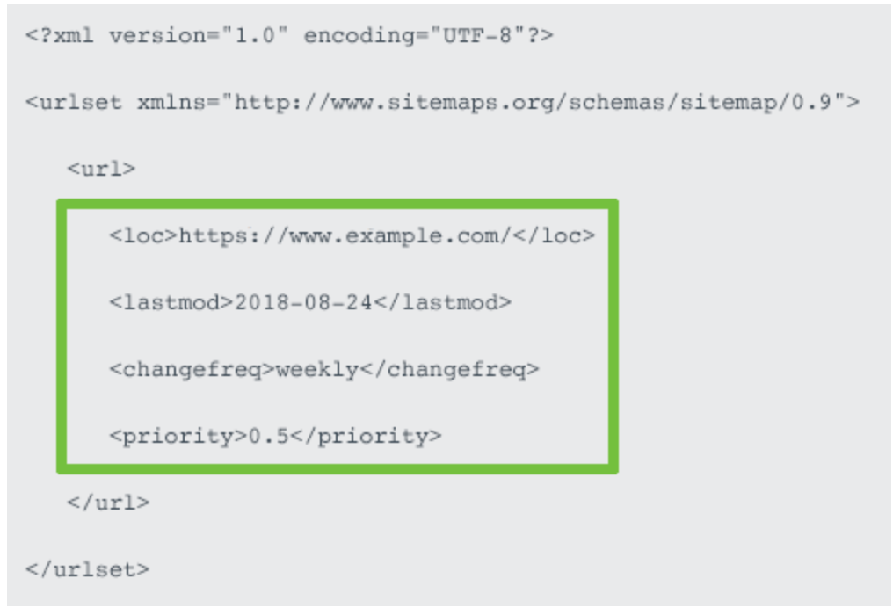

* + Should contain **location tag.**
    - Should accurately reflect your site protocol (**http or https)** and if you have chosen to include or exclude **www.**
  + **Last modified date**
  + **Priority Tag**
* Limitations of XML sitemap
  + A maximum of 50000 urls
  + Uncompressed file size of 50mb
* After creating sitemap add them to google, yahoo and bing webmaster tools.
* Add your sitemap path to **robots.txt file.**
  + 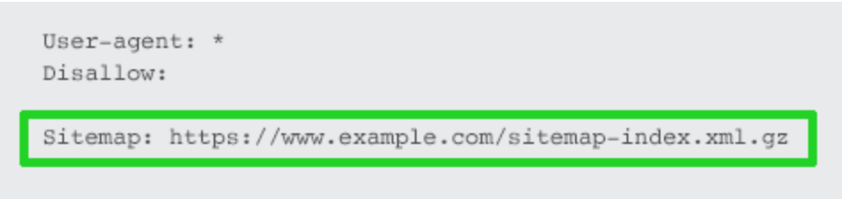
* **Optimizing sitemap**
  + Only include SEO relevant pages in sitemap.
  + **Exclude:**
    - Non-canonical pages.
    - Duplicate pages.
    - Paginated pages.
    - Parameter or session ID based URLs.
    - Site search result pages.
    - Reply to comment URLs.
    - Share via email URLs.
    - URLs created by filtering that are unnecessary for SEO.
    - Archive pages.
    - Any redirections (3xx), missing pages (4xx) or server error pages (5xx).
    - Pages blocked by robots.txt.
    - Pages with noindex.
    - Resource pages accessible by a lead gen form (e.g., white paper PDFs).
    - Utility pages that are useful to users, but not intended to be landing pages (login page, contact us, privacy policy, account pages, etc.).
* If number of url exceeds then use [sitemap index file](https://support.google.com/webmasters/answer/75712?hl=en).
  + Use descriptive sitemap names that reflect your site structure.
  + Don’t set the sitemap name as sitemap1, sitemap2, sitemap3, instead follow the structure of your website and name accordingly,
  + Such as project sitemap should be **/sitemap/projects,** organization should be **/sitemap/organization.**

**Metrics for Checking**

* **Speed**
  + Loading time of the site should be less.
  + Tools for site-speed:-
    - Web page test
    - Google PageSpeed Insights
    - Google lighthouse
    - Pingdom tools
  + Things to improve site-speed:-
    - Enable compression of your website file using compressing tools such as [GZIP](https://www.gnu.org/software/gzip/).
    - Minify css, javascript, HTML
    - Reduce redirects
    - Remove render blocking javascript
* Security
  + Website secured with SSL.
  + Use of HTTPS over HTTPS.
* Crawlability
* Accessibility
  + Test your site with disabling styles
    - See if the quality and semantics of HTML are done right.
    - There is a logical grouping of elements and the structure is clear
  + Unplug your mouse and use the keyboard for navigation
    - Any user interface, including websites, should be fully operable regardless of the device used to interact with.
  + Check the contrast
    - The most frequently used requirement for this is to guarantee a contrast of at least 4.5:1 between text and background.
    - Very big text can have a lower ratio of 3:1.
    - Check contrast on [color contrast analyser](https://developer.paciellogroup.com/resources/contrastanalyser/).
  + Use accessibility evaluation tools
    - [Webaim Wave](https://wave.webaim.org/extension/)
    - [Deque Axe](https://www.deque.com/axe/)

**Tools**

|  |  |
| --- | --- |
| **FOR** | **Tools** |
| **Keyphrase Searching** | * Using Google Adwords Keyword Planner, * Yoast Suggest * Google Trends * Internal search engine * [Answerthepublic](https://answerthepublic.com/) |
| **Sitespeed Checking** | * Web page test * Google PageSpeed Insights * Google lighthouse * Pingdom tools |
| **Structured Data** | * [**JSON-LD**](https://json-ld.org/) * Schema.org * [google structured data markup](https://search.google.com/structured-data/testing-tool/u/0/) |
| **Structured Data testing** | * [Structure Data testing](https://search.google.com/structured-data/testing-tool/u/0/) |
| **SEO Tools** | Google analytics, google search console |
| **Crawlability Check** | Google search console. |
| Accessibility evaluation tools | * [Webaim Wave](https://wave.webaim.org/extension/) * [Deque Axe](https://www.deque.com/axe/) |
| User testing for CRO (conversion rate optimization) | [abtestguide.com](https://abtestguide.com/calc/). |
| Reducing image file size | * [ImageOptim](https://imageoptim.com/mac) * [JPEGmini](https://www.jpegmini.com/) * [jpeg.io](http://jpeg.io) * [Kraken.io](https://kraken.io/) |
| Compression of File | [GZIP](https://www.gnu.org/software/gzip/). |
| Mobile friendly test | [Mobile friendly test](https://search.google.com/test/mobile-friendly) |
| Google Webmaster | <https://www.google.com/webmasters/#?modal_active=none> |
| Sitemap | [Sitemap Index](https://support.google.com/webmasters/answer/75712?hl=en)  [Schema Sitemap](https://www.sitemaps.org/protocol.html)  [Creating Site Map](https://support.google.com/webmasters/answer/156184) |

* Mobile Friendliness
  + Is your website compatible with mobile.
  + Test loading time on mobile devices.
  + Design for mobile
    - Don't use flash and pop ups.
  + Use google [Mobile friendly test](https://search.google.com/test/mobile-friendly) to check mobile friendly
  + <https://moz.com/learn/seo/mobile-optimization>